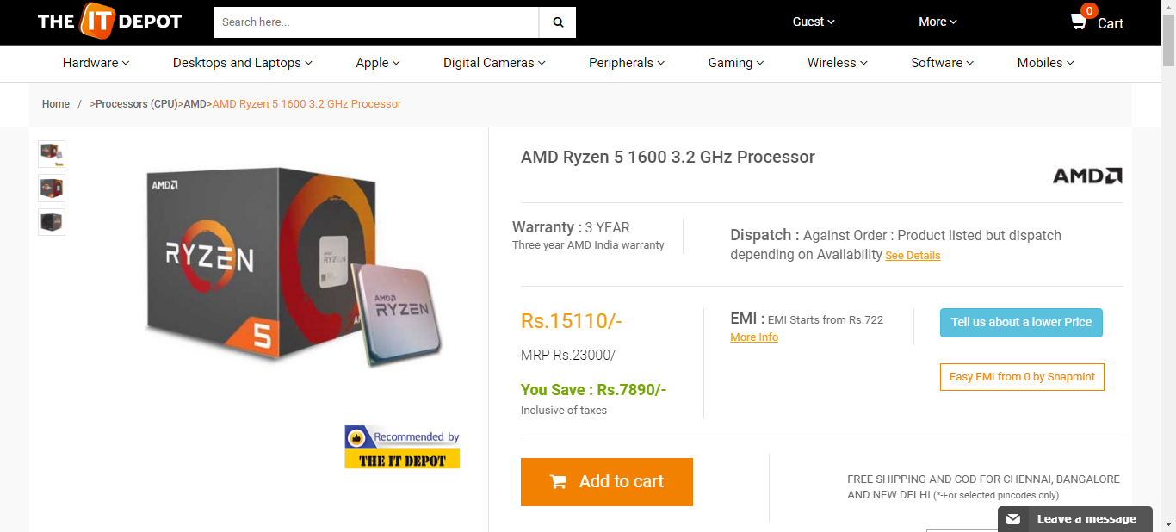  
theitdepot_processor_19_08_2018_10_09

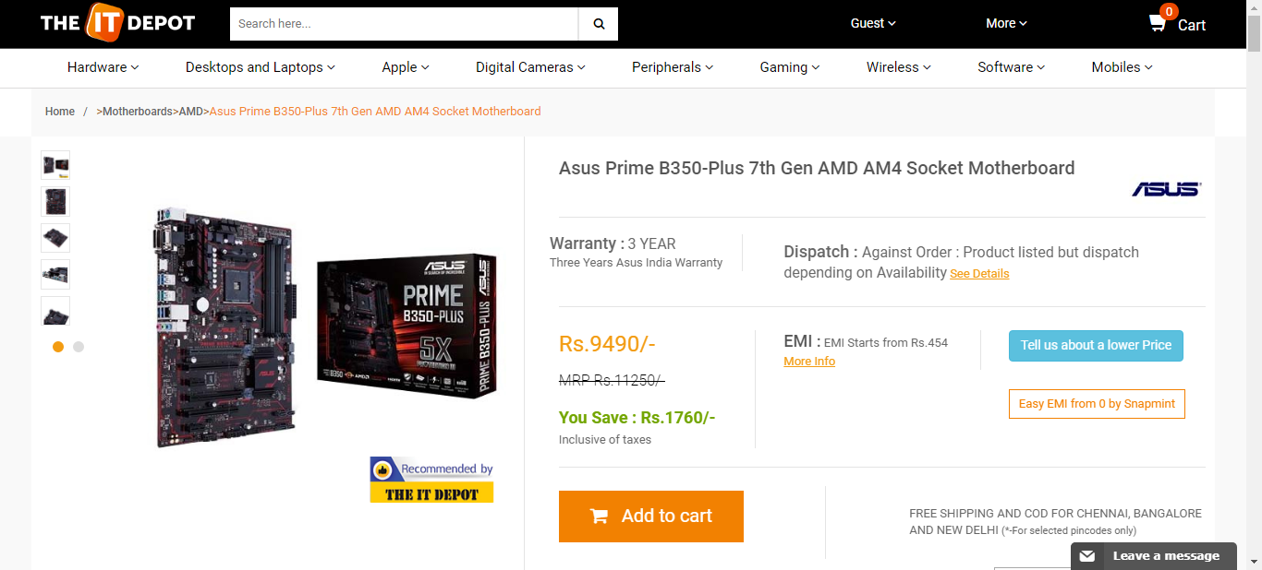  
theitdepot_motheboard_19_08_2018_10_09

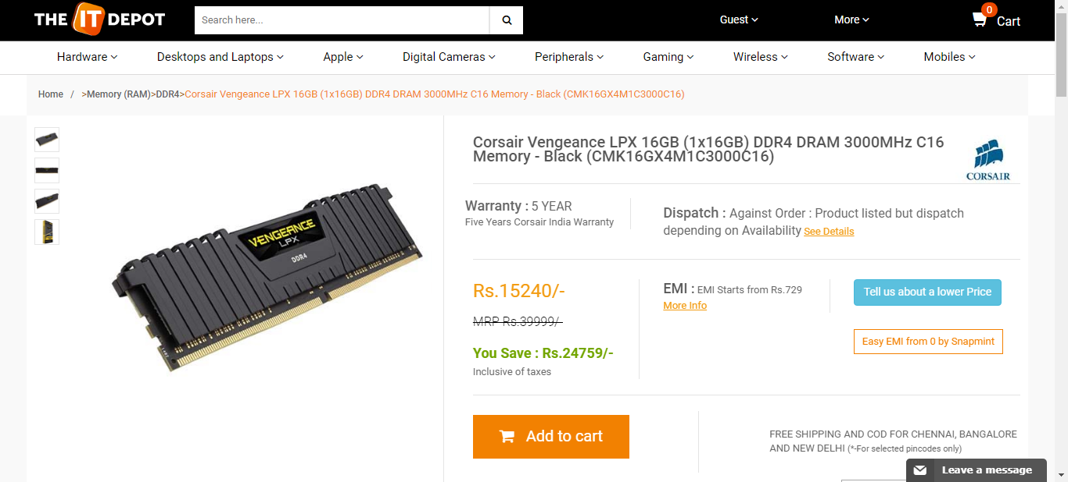  
theitdepot_ram_19_08_2018_10_09

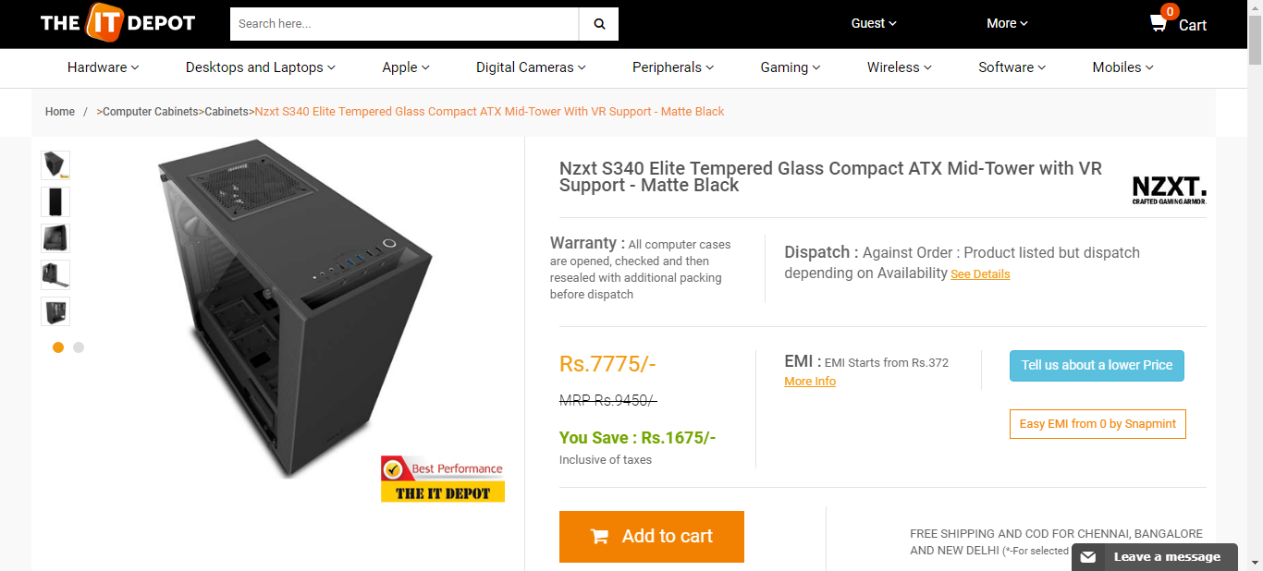  
theitdepot_cabinet_19_08_2018_10_09

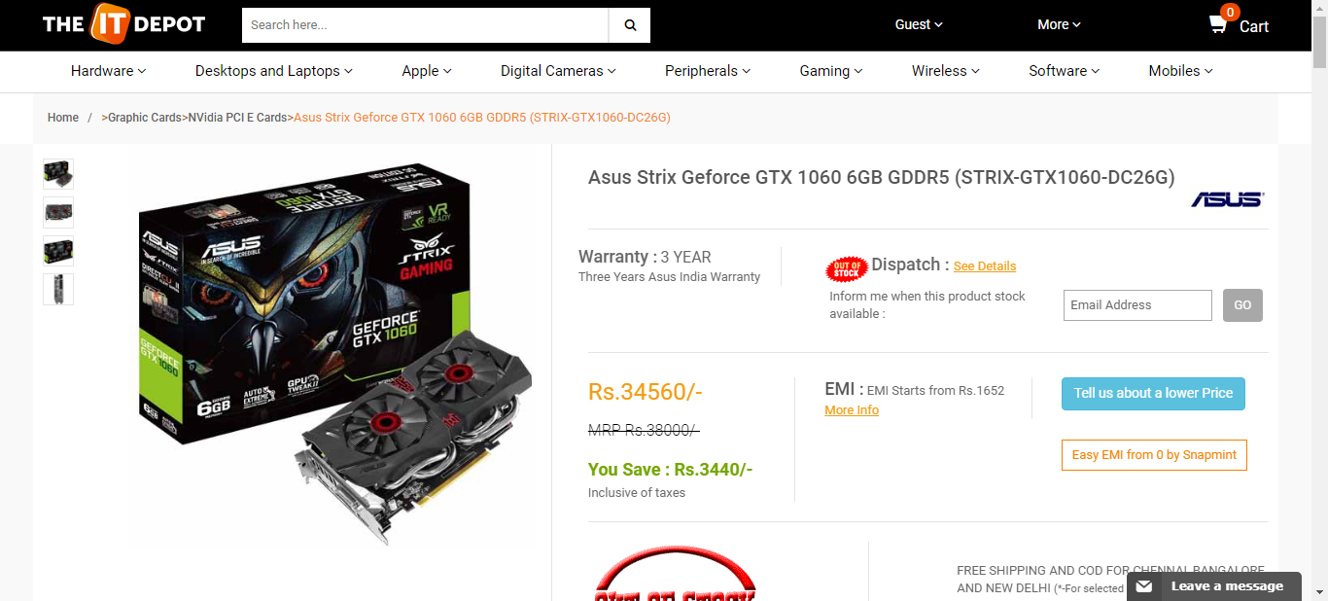  
theitdepot_graphicscard_19_08_2018_10_09

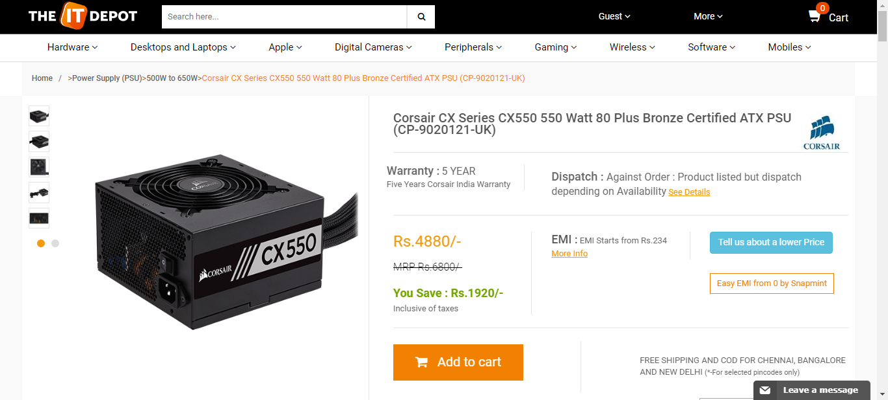  
theitdepot_powerSupply_19_08_2018_10_09

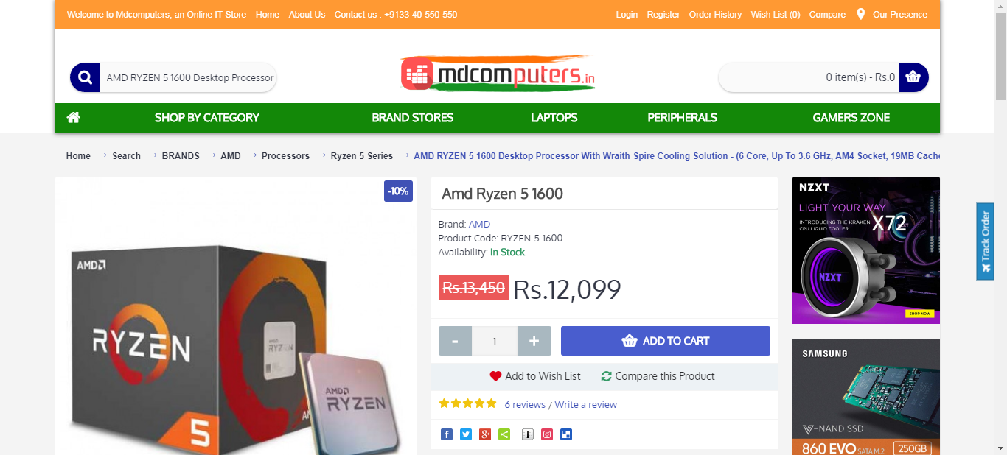  
mdcomputer_processor_19_08_2018_10_09

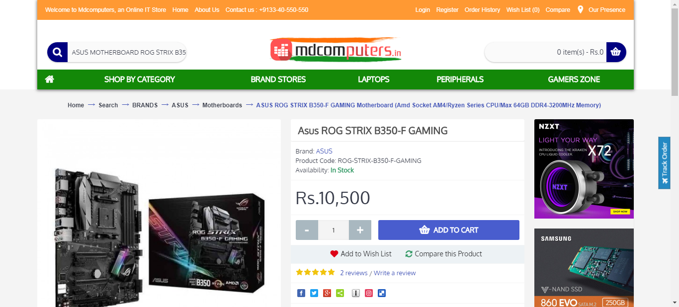  
mdcomputer_motherboard_19_08_2018_10_09

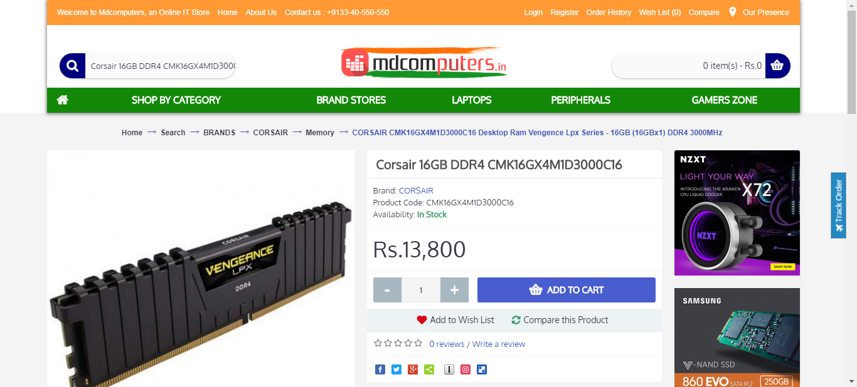  
mdcomputer_ram_19_08_2018_10_09

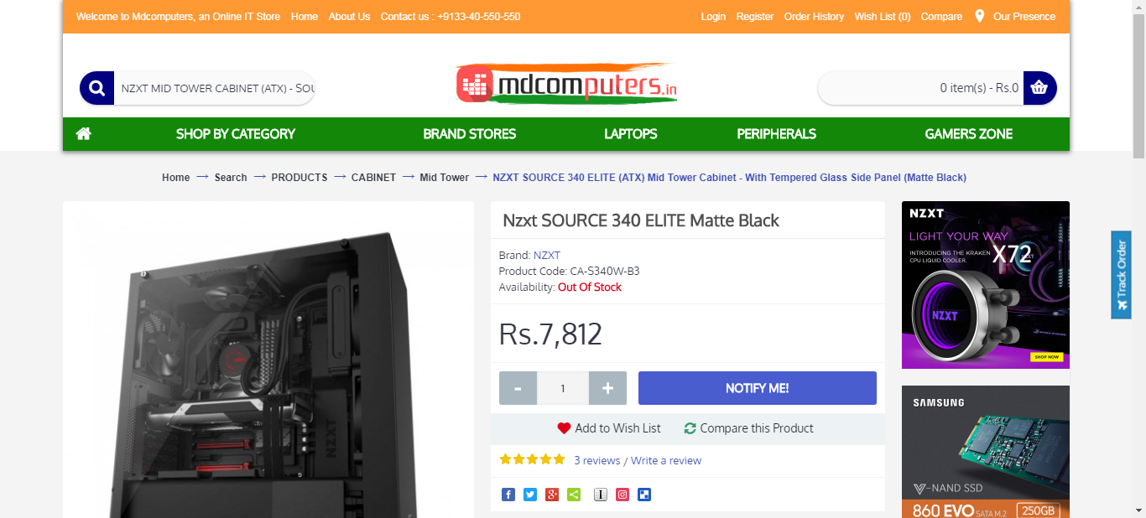  
mdcomputer_case_19_08_2018_10_09

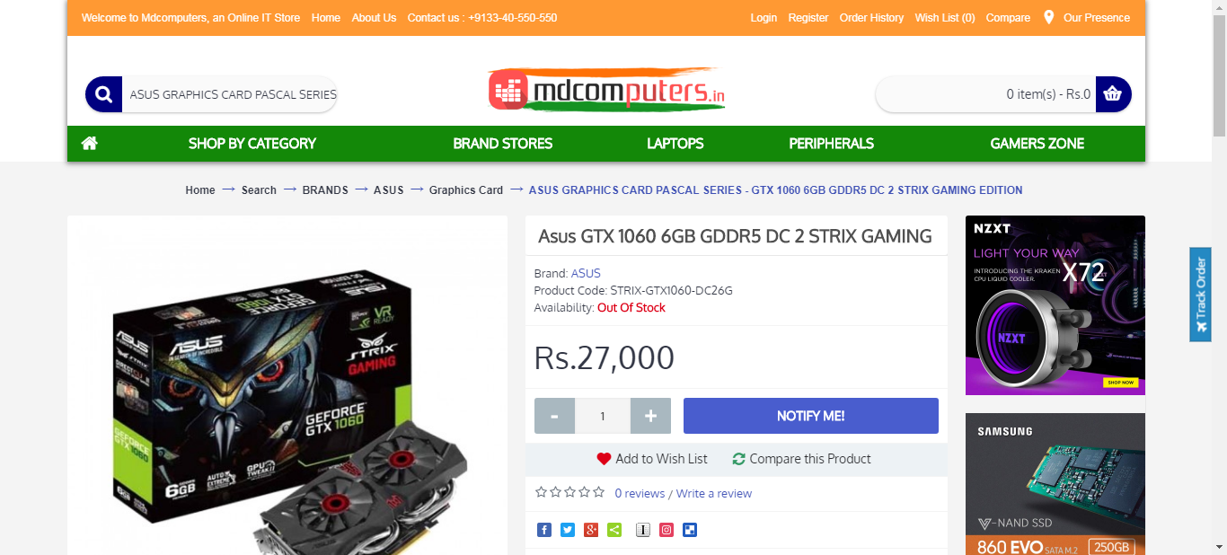  
mdcomputer_graphicsCard_19_08_2018_10_09

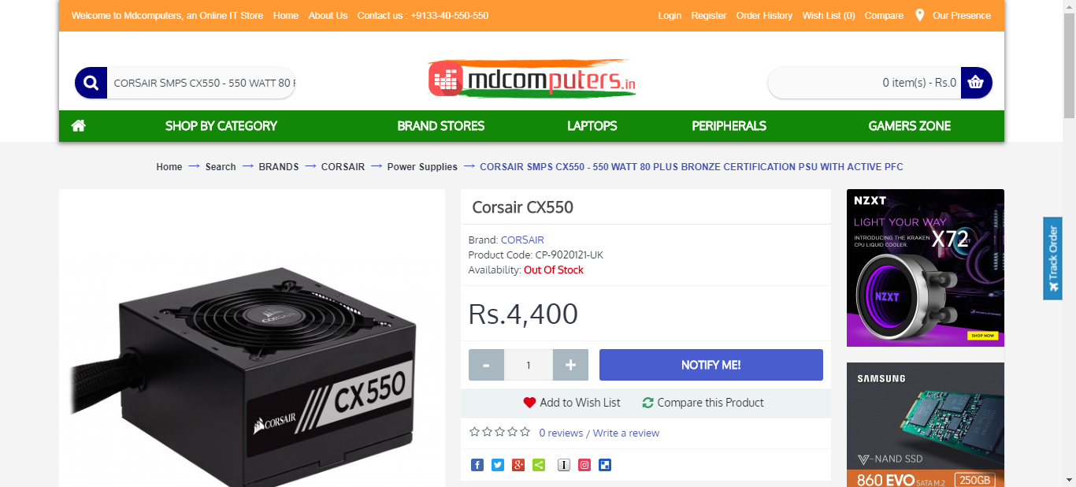  
mdcomputer_psu_19_08_2018_10_09

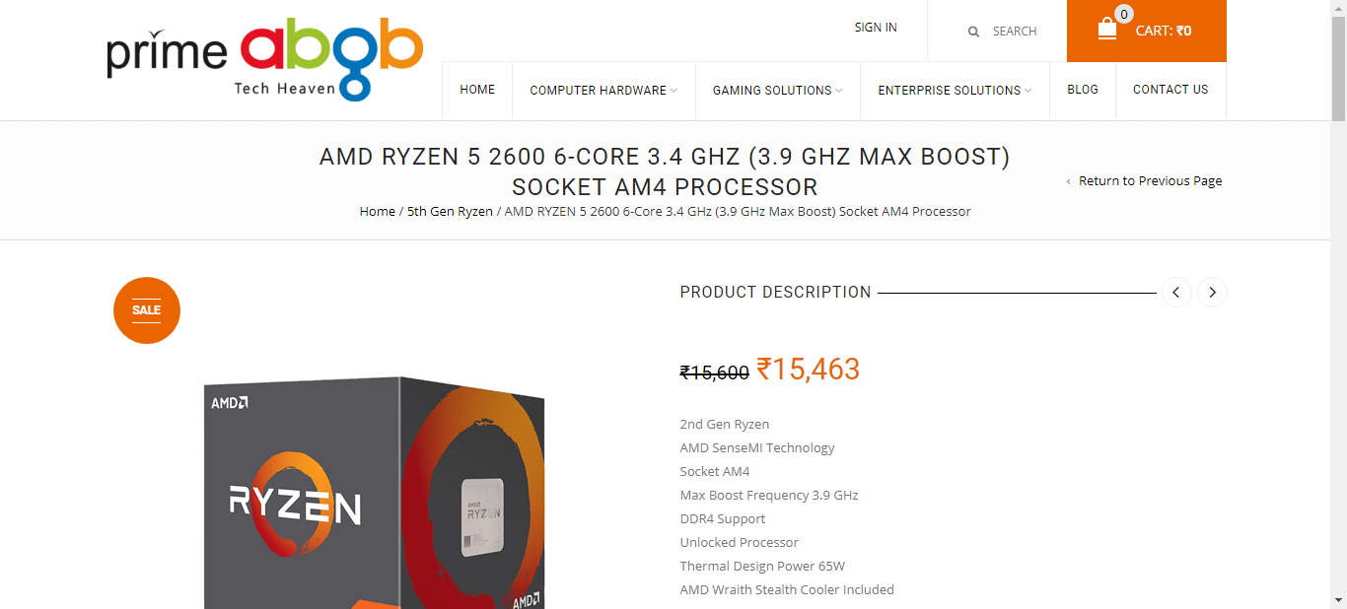  
primebgb_processor_19_08_2018_10_09

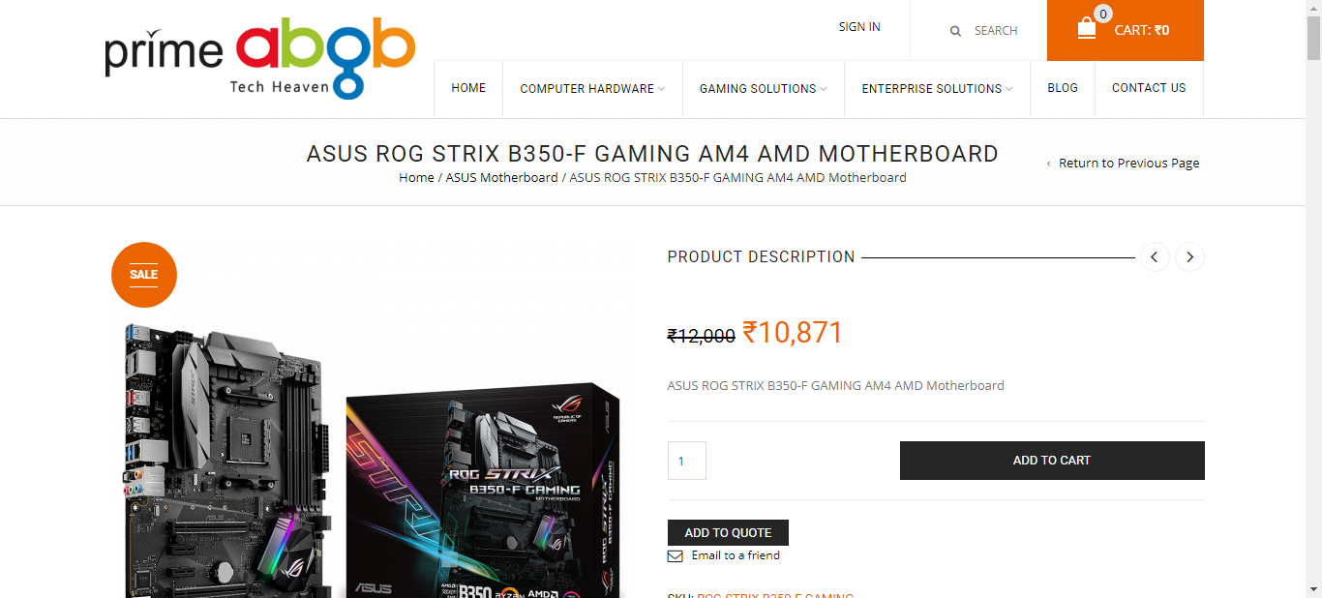  
primebgb_motherboard_19_08_2018_10_09

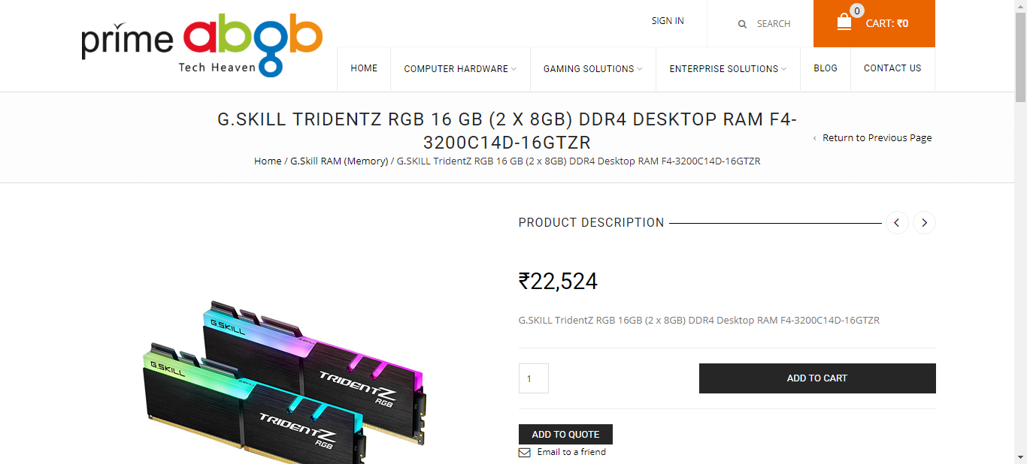  
primebgb_ram_19_08_2018_10_09

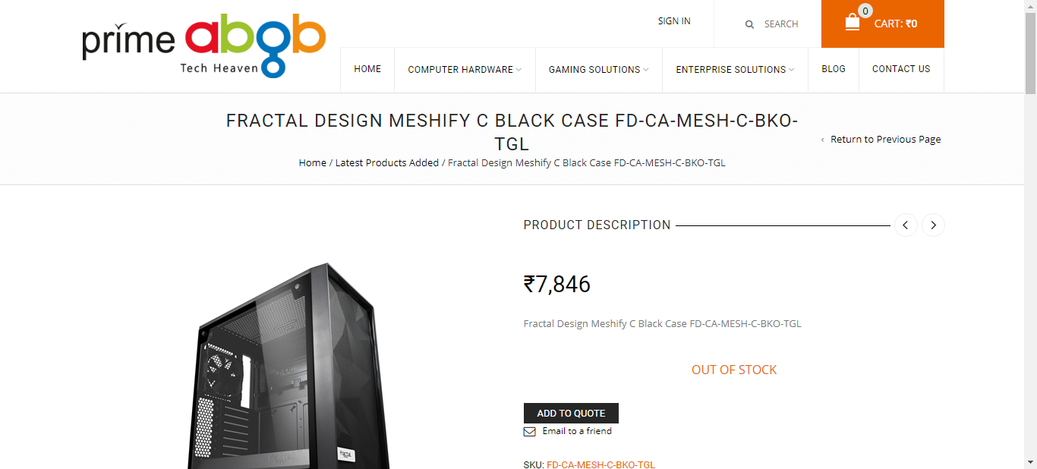  
primebgb_case_19_08_2018_10_09

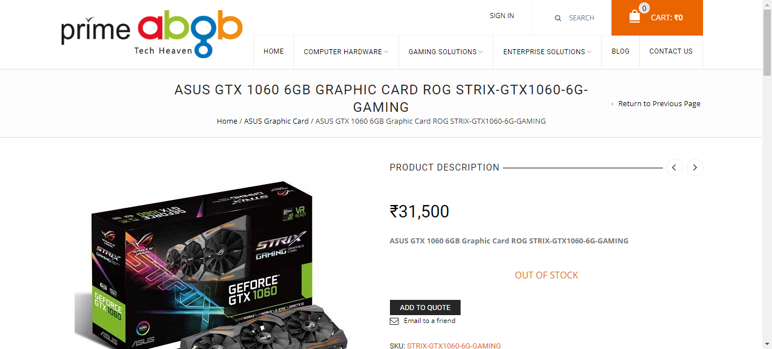  
primebgb_graphicsCard_19_08_2018_10_09

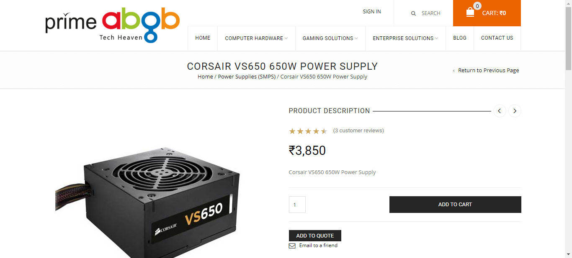  
primebgb_psu_19_08_2018_10_09